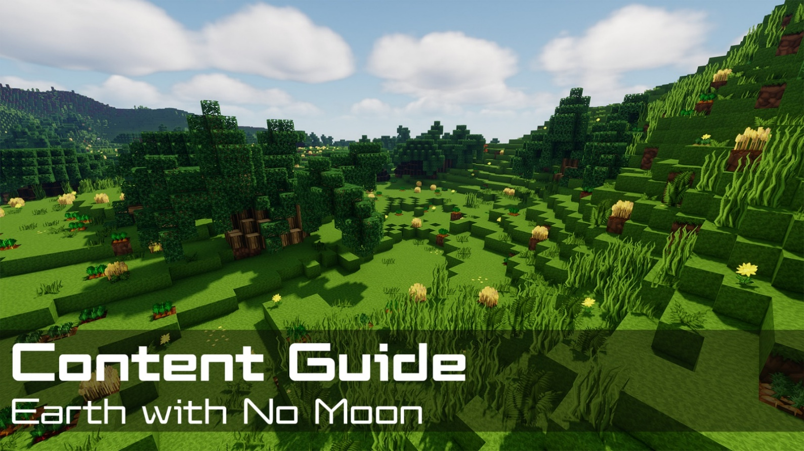
Contents  📖 Narrative Focus 3  World Overview 3  🎯 Objectives 4  🏫 Standards Alignment 4  📝 Assessments 4  💡 Tips for Instruction 5  🔭 Observable Concepts and Points of Interest 6  ❓ Expected Questions 7  🔬 Connected Classroom Activities 7  ☑️ World Quest Progression 7  🗺️ Map 8  👩🏽‍🔬 NPC's and Their Roles 8 | How to Use This Guide  This content guide is intended for parents, librarians, teachers, and other educators who are interested in facilitating learning experiences with the WHIMC server, in home or classroom-based settings. It reviews all the critical components of a given WHIMC world as well as what might be learned in it.  This world is the 5th players encounter, for a full overview of world order, see the teacher guide home page.  More information about project WHIMC can be found on our website at whimc.org. Teachers and participants unfamiliar with computer-based Minecraft: Java Edition can learn how to install and control the game here as well.

📖 Narrative Focus
Earth with No Moon serves as a first exploration of the "what-if" worlds. As a very basic form of a "what-if" Earth, players will learn about several science-relevant variables and tools as well as see more ways to use the observation tool, a quintessential part of the process of exploring and discovering the server. They will also be introduced to quests and maps for navigation. After this world is completed, players will have a set expectation for "what-if" world format, and will be able to explore the others on the server more easily. More importantly they’ll develop a sense of just how important the moon is and what it affects.

World Overview

Faster Rotation & Stronger Weather
- Without the Moon slowing Earth’s spin, days might last only 8–12 hours
- Faster rotation would create stronger jet streams, harsher storms, and more violent hurricanes
- Plants would evolve to survive constant high winds and rapid weather shifts – like the shorter trees found all in the valley on this map

Unstable Climate, Extreme Seasons and Weaker Tides
- The Moon stabilizes Earth’s tilt; without it, the planet could wobble dramatically over time
- Wildly shifting climate zones would mean ecosystems would face frequent disruption
- Solar tidal pull alone would be much weaker than our earth’s lunar + solar tides
- Coastlines would have fewer marshes, estuaries, intertidal ecosystems and less coastal biodiversity

Darker Nights & Differences in Evolution of Life
- Nights would be far darker without moonlight
- No lunar cycles would affect animal navigation, breeding, and migration patterns
- Human culture would lack lunar calendars, eclipses, and many Moon-inspired myths and traditions – people may have never found the inspiration to explore outer space!

Magnetic Field and Atmospheric Composition
- Rapid rotation combines with the thermal convection of its molten metallic core to churn charged magma faster than on Earth, generating a magnetic field nearly three times stronger
- Without a moon-forming impact to strip away early gases the thick, carbon dioxide-dominated primordial atmosphere gradually thinned out as the oceans absorb the gas and early marine life converted the remainder into oxygen

🎯 Objectives
- Transition to open-ended exploration (fewer quests) but with a smaller environment
- Compare characteristics of this earth to our earth, start thinking about what effects habitability
- Learn that sources of energy depend on the environment in which they are collected
- Continue practicing use of science tools, observations, quests and the minimap

🏫 Standards Alignment
Next Generation Science Standards (reference)
- K-ESS2.D: Weather and Climate
- 1-ESS1.A: The Universe and its Stars
- 1-ESS1.B: Earth and the Solar System
- 2-ESS2.A: Earth Materials and Systems
- 4-ESS2-1: Make observations and/or measurements to provide evidence of the effects of weathering or the rate of erosion by water, ice, wind, or vegetation.
- 4-ESS2.A: Earth Materials and Systems
- 4-ESS3.A: Natural Resources
- MS-ESS1-2: Develop and use a model to describe the role of gravity in the motions within galaxies and the solar system.
- MS-ESS1-3: Analyze and interpret data to determine scale properties of objects in the solar system.
- MS-ESS1.A: The Universe and Its Stars
- MS-ESS1.B: Earth and the Solar System
- MS-ESS2.B: Weather and Climate
- MS-ESS3.A: Natural Resources

📝 Assessments
During WHIMC camps, instructors provide opportunities for students to express what they have learned in the form of short answer questions. Over time, these have taken two forms: ICAN Prompts and Self-Explanations. While teacher content guides are designed for those outside of WHIMC researcher-run camps, these prompts can be used to facilitate discussions about the server and what was learned during a playthrough of a particular world.
Self-Explanations
No Moon Questions | Why is the wind speed faster without a moon? | What is one consequence you observed of having higher wind speeds? | Could humans survive on No Moon? Why?
Possible Answers | Wind currents are determined by tides, which are much less without the gravitational pull of the moon | Wind turbine, short stubby plants that are more distributed, areas outside of valley stripped of growth | They see evidence that yes they could but this is critical thinking about what people need

Quest participation can be an indicator of engagement. This map is part of the larger series of Explore [What-If] Earths and contains Observe with the Wind, which is required for progress to any other worlds. They are both required quests and just indicate a baseline minimum for completion.
On every world there are main concepts and science variables that can be observed. Instructors can expect a minimum of 2 observations of substantive quality and 2 different science measures to consider a learner to be at a level of satisfactory engagement on No Moon.
ICAN Prompts (retired)
ICAN explain what the Earth would be like without a moon and reasons why. | ICAN tell you what Earth would be like if the sun is colder and reasons why. | ICAN share one question I have about a what-if world I saw today.

💡 Tips for Instruction
- Playing through the world and knowing locations can benefit greatly for students, as finding the locations of different geographic features or landmarks can be difficult.
- Videos discussing the science behind Earth with no moon can be found here (part 1) and here (part 2)
- Players should talk with every NPC in order to grasp the point of the area, as simply walking around will not tell them enough to understand.
- There are multiple required quests here, make sure students complete them before moving on to a different "what-if" world.
- Have students utilize the /observe command to the fullest extent possible, with all of the different menus as well as just the baseline.

🔭 Observable Concepts and Points of Interest
To see a list of all available science tools, simply type /sciencetools measure into the in-game chat, press space, and then use the arrow keys to scroll through the list of available options.
World-wide (regions: __global__ or perimeter)
/tides - variance is 1/3 that of Earth
/wind - significantly higher than what is on the control Earth, floating hint to observe wind
/tilt – 0 degrees, it would never have been knocked on it’s side by collision
/magnetic_field – 3 times stronger than regular earth
/atmosphere - 1% carbon dioxide, 75% nitrogen, 1% argon, 23% oxygen
Night sky lacks a moon
Power control station, welcome center (regions: poi_turbine_control, poi_welcome_center)
/wind, /airflow - 0.30 m/s
/atmosphere - 78% nitrogen, 21% oxygen, 0.9% argon, 0.04% carbon dioxide
Greenhouse (regions: poi_greenhouse)
/temperature - around 27 C (80.2 F) (299.9 K)
/humidity – 75% to 85%
Bodies of water
/pressure - around 20kPa higher submerged in the water
/humidity - 100%
/temperature - around 4 C colder than the air while submerged
Visible geographic features
Trees and short bushes (region: poi_valley)
Hills surrounding (players are in a valley)
Wind turbine (region: poi_turbine)
Coastal areas are stripped of all grass (regions: poi_coast_east/west/south/north)

❓ Expected Questions
Questions Kids Might Ask | Questions Facilitators Might Ask
What if Earth had no moon?  Why is the wind so fast?  How did the trees get so large?  Why are the plants so spread apart?  How do they get energy here?  Why is there no grass on the mountain?  How did these craters get here? | Would night time be different on this earth?  Do you think ocean life would be affected?  If we didn’t have a moon would there be a space race or interest in exploration?  Was there anything in this level that surprised you?  Where did you explore? Who did you meet?  What questions do you have?

🔬 Connected Classroom Activities
Demonstration with a squish-ball or drawing to explain how the gravity of the moon impacts tides on Earth
Show strengthening garden seedlings with a fan
Explanations and Explorations:
- How was the moon formed?
- What are tides?
- How do wind currents work around Earth?
- How do wind turbines work?
- How does the moon impact plant and animal life?

☑️ World Quest Progression
In order to exit this world, players need to successfully place an observation – it is strongly hinted they take a look at the /airflow or /wind and compare it to that of regular (control) earth.

🗺️ Map
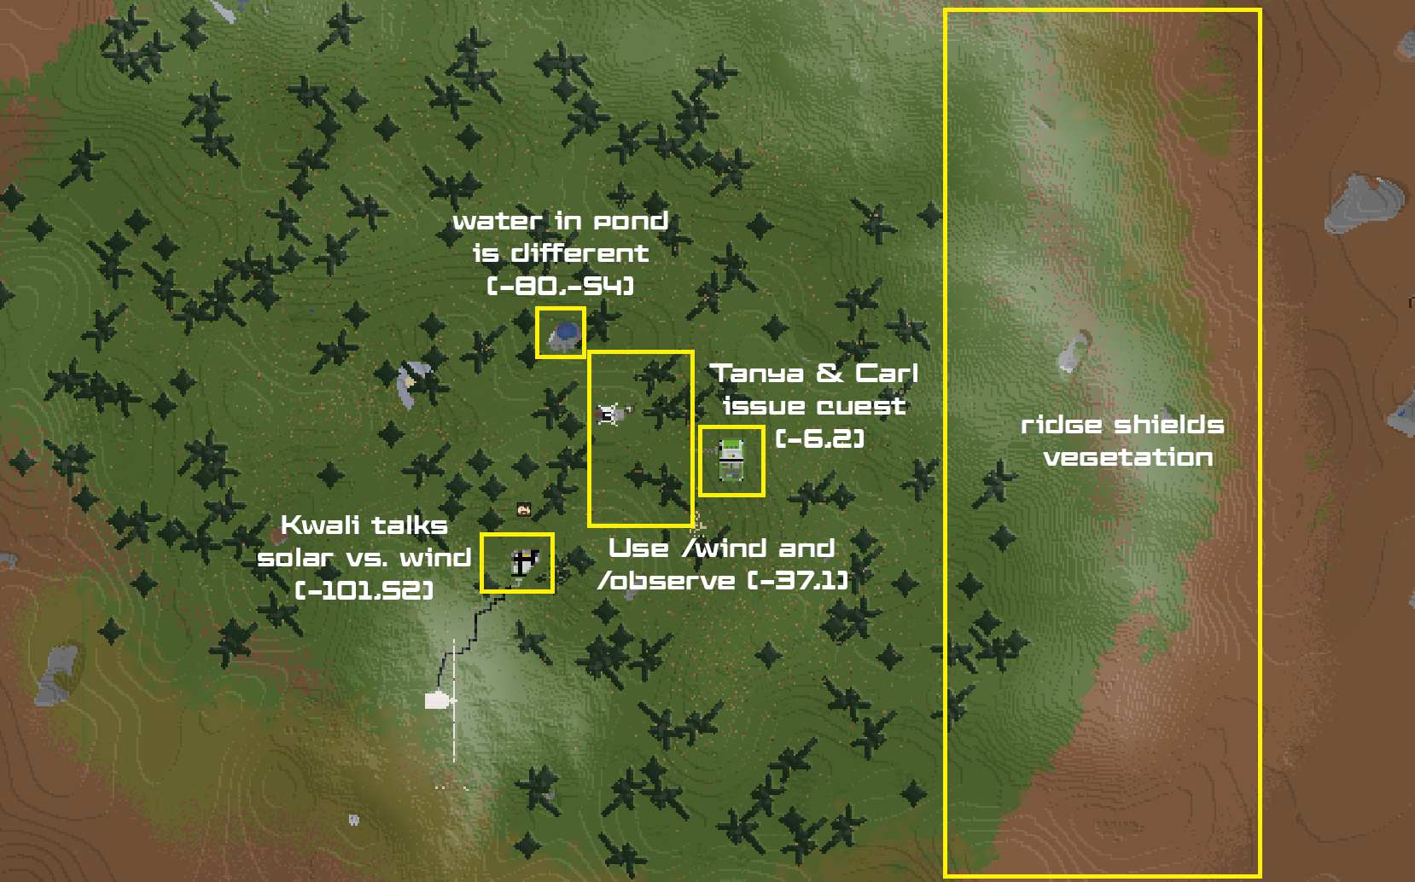

👩🏽‍🔬 NPC's and Their Roles
A non-player character (NPC) is a video game character that is controlled by the game's artificial intelligence (AI) rather than by a player. The NPC’s below are those that are tied to quests on the server or that offer relevant STEM information – there are others who may be present but not mentioned in this guide.
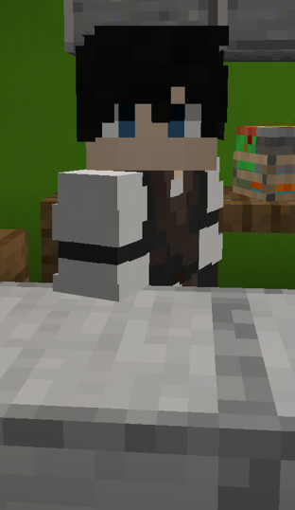 | Located at  x: -2  y: 74  z: 1  ID: 108 | [Travel Authority] Carl S. - Checkpoint for the "What-If" quest loop, prompts players to use the /observe command and tells them to visit the green house to talk to Tanya.
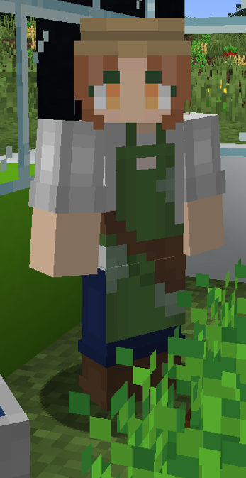 | Located at  x: -1  y: 74  z: 12  ID: 109 | [Botanist] Tanya J. - Explains need for a greenhouse for taller plants and assigns the Observe with the Wind quest, which is a requirement for players to leave the planet - hopefully they'll notice powerful wind but also infer this impacts plant growth.
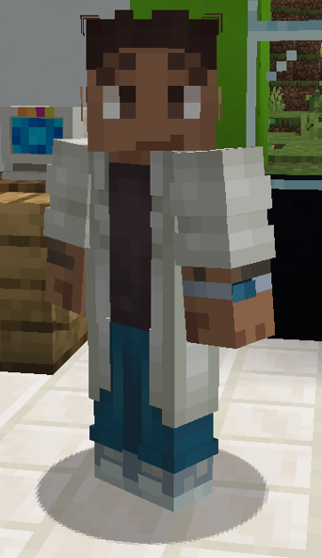 | Located at  x: -101  y: 74  z: 52  ID: 193 | [Electrical Engineer] Kwali T. - Points out stronger wind, invites players to wonder why it might be more effective than solar power on this Earth; gets them thinking about the affordances of different green energy.

